Verdyol Biotic Earth™ Black Specification Examples
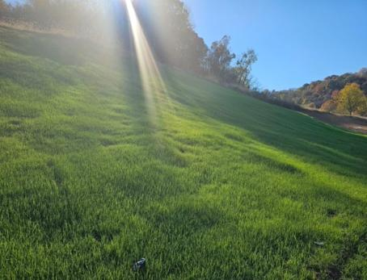
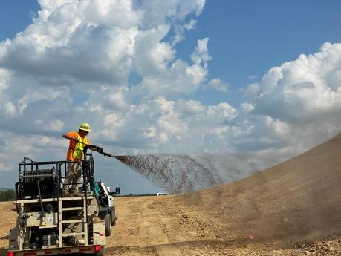
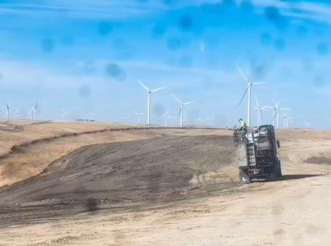
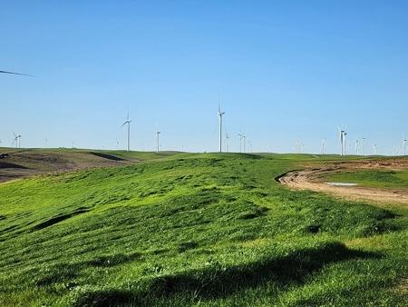
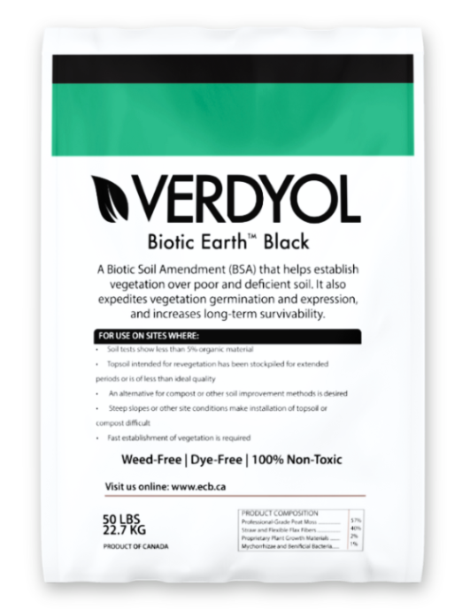

Thank you for downloading our: Verdyol Biotic Earth™ specifications. You can cut and paste a few options into your construction documentation. This document's content is free to use, and if you need further assistance, please call or email.

Alex Zimmerman
alex@ecb.ca
1-360-910-4800
_________________________________________________________________________________________________

Product Specifications

Verdyol Biotic Earth™ Black is specifically designed to assist in creating a suitable growth medium for establishing vegetation over poor and deficient soil. It is also designed to speed up the vegetation establishment and full expression and increase the survivability of vegetation where used. This product is designed for hydraulic application, but dry application (hand spreading) is also acceptable.

For Use on Sites Where:

- Soil tests show less than 5% organic material
- Where topsoil intended for revegetation has been stockpiled for extended periods or is of less-than-ideal quality
- As a replacement for compost or other soil improvement methods
- Steep slopes or other site conditions make installation of topsoil or compost difficult
- Where fast establishment of vegetation is required
Please note: Verdyol Biotic Earth™ Black is a soil improvement product, so an adequate and separate erosion control product (RECP, TRM, or hydraulic) is recommended for site protection.
Performance Properties
Vegetation Establishment and Germination Improvement | ASTM D7322* | % | 1502%
Average Plant Height | ASTM D7322* | % | 308%
Plant Mass per Area | ASTM D7322* | % | 419%
Material and Environmental Properties
Organic Material | ASTM D586 | % | >95
Water Holding Capacity | ASTM D7367 | % | 1020%
pH | Saturated Media Extract Method | n/a | 6 +/- 1
C: N Ratio | Independent laboratory | n/a | 35:1 (+/- 10)
Natural Material Color (Dye Free) | Observed | n/a | Dark Brown/ Black
Moisture Content | Independent laboratory | % | 30.50%
Acute Toxicity | EPA TM 2002.0 | n/a | 100% Non-Toxic
Foreign Seed Content | Viability Analysis | % | 0%
Product Composition
Professional Grade Peat Moss |  | % | 57%
Thermally and Mechanically Processed Straw and Flexible Flax Fiber |  | % | 40%
Trace Minerals, Plant-Based Biodegradable co-polymer, sugars, starches, proteins, and 16 amino acids (including folic acid, vitamin A, and triacontanol growth stimulants/ regulators) |  | % | 2%
Multiple Species of Both Mycorrhizae and Beneficial Bacteria |  | % | 1%
Material Viability
Biotic Earth moisture content ensures microbial viability in excess of 75% for two years from the date of manufacture.
Packaging Properties
Bag Weight | Scale | kg (lb.) | 22.7 (50)
Bags per Pallet | Observed | # | 42
UV and weather-resistant bags. Pallets are weatherproof stretch stretch-wrapped with a
UV-resistant pallet cover. Dates of manufacture are listed per bag.
*Percentages are the average of 7, 14, and 21-day results of ASTM D7322
To the best of our knowledge, the information contained herein is accurate. However, ECBVerdyol cannot assume any liability whatsoever for its accuracy or completeness.

Product Citation Materials Specific Specification

XX. Mulch
XX. Hydraulic Growth Medium and Biodegradable Growth Medium Method

Mulch shall be biotic-active hydraulically applied mulch such as “Verdyol Biotic Earth™ Black”, or an approved equal. Any approved equal must include the following material composition:

Material Composition:

- 40% by volume of thermally and mechanically processed straw and flexible flax fibers
- 57% by volume of professional-grade sphagnum peat moss
- 1.26% by volume of other valuable tracer minerals, sugars, starches, proteins, fiber and 16 amino acids, including folic acid, Vitamin A, triacontanol growth stimulants/regulators
- 1% by volume mycorrhizae

Laboratory Analysis:

- Total Organic Matter Content = >95%
- Carbon: Nitrogen Ratio = 31:1
- Moisture Content = 44.5% +/- 5%
- pH = 5.5 (Saturated Media Extract Method)

Materials Specific Specification:

Soil Amendment:

Soil amendment shall be a pre-packaged, commercially available, hydraulically applied blend of natural fibers, mycorrhiza, growth stimulants, and other biologically active material designed to improve seed germination and vegetation establishment.

Soil amendment shall be manufactured from thermally and mechanically processed straw and flexible flax fibers, sphagnum peat moss and other biological additives at the following volumes:

- 35-45% by volume of thermally and mechanically processed straw and flax fibers
- 50-60% by volume of professional-grade sphagnum peat moss
- 1-2% by volume of other biological additives, including trace minerals, sugars, starches, proteins, folic acid, vitamin A, triacontanol and triacontanol growth stimulants/regulators
- <1% by volume of fungal mycorrhiza and plant-beneficial bacteria

Installation & Mixing Guide

This is in an image format. Right click and save to your computer.

